Alexandria University CS221: Programming - 2

*Faculty of Engineering*

*Computer and Systems Engineering Dept.*

*Second Year*



**JDBC**

**Names:**

1. Ahmed Magdy
2. Hesham El-Sawaf
3. Mahmoud Hussein
4. Marwan Tammam

* ***UML Diagram***
* Packages.

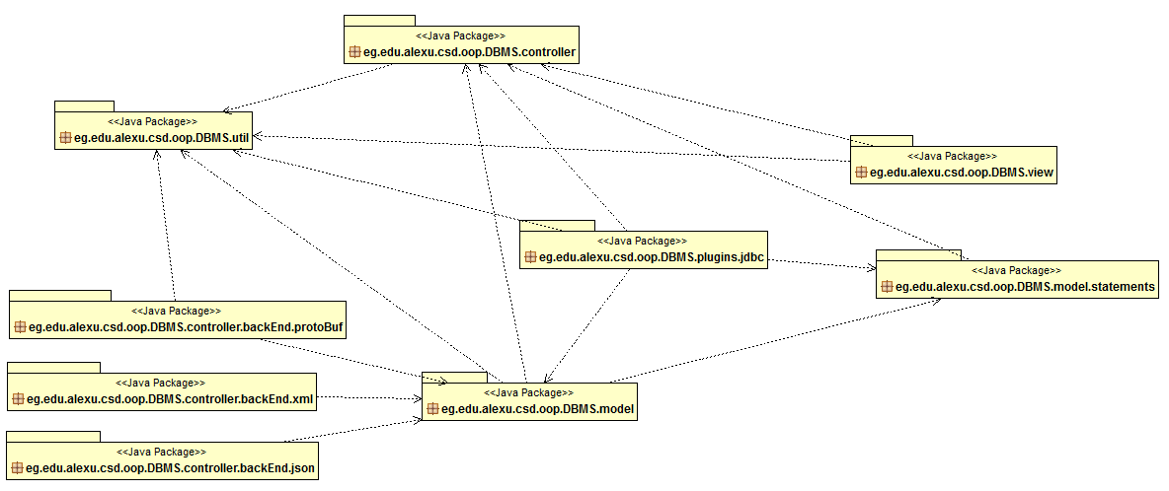

* Plugins.JDBC.

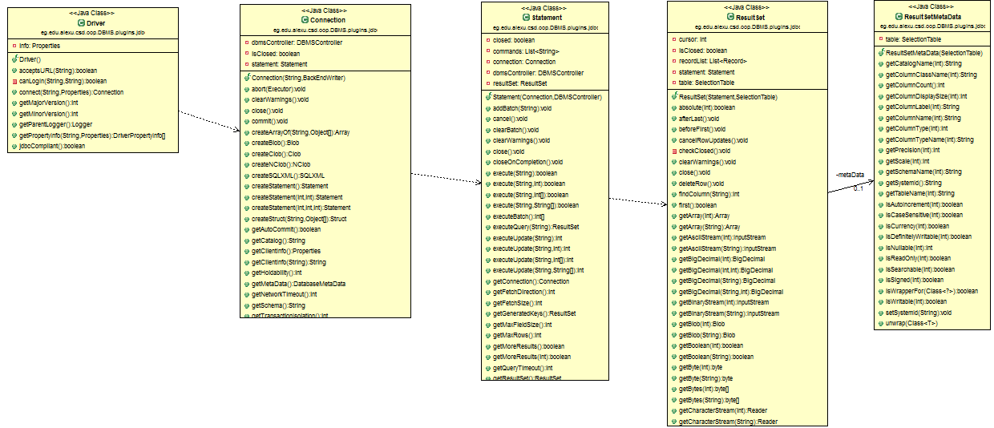

* Controllers.

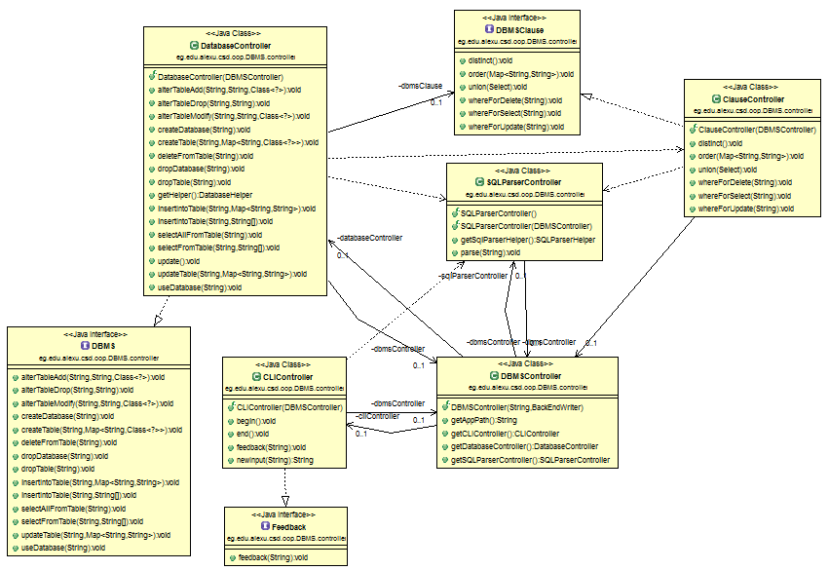

* Back end writers (XML, JSON and protocol buffers).

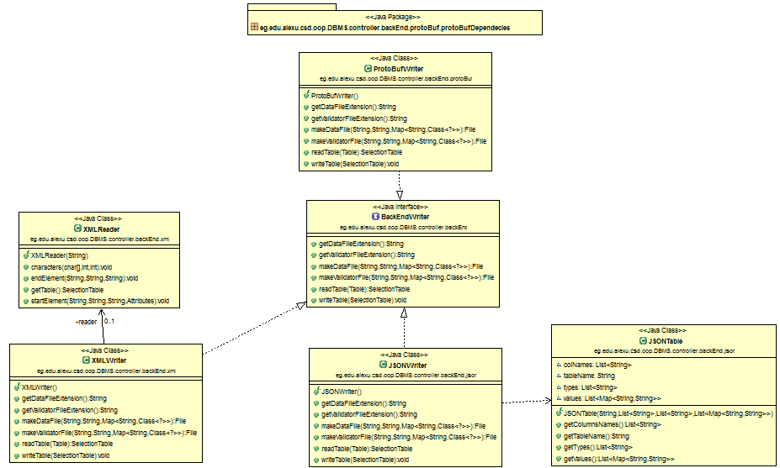

* Model.

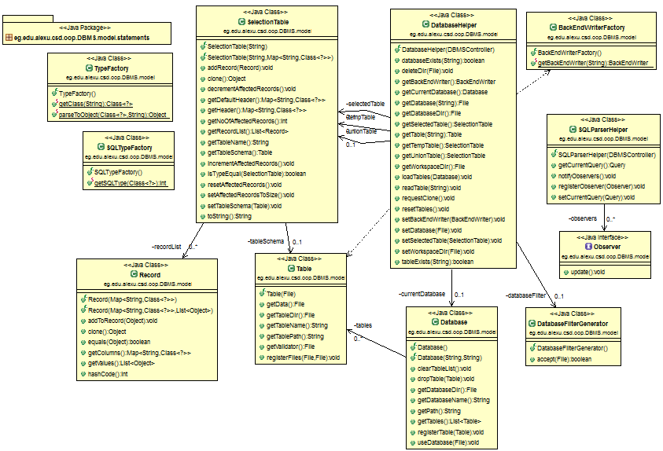

* statements

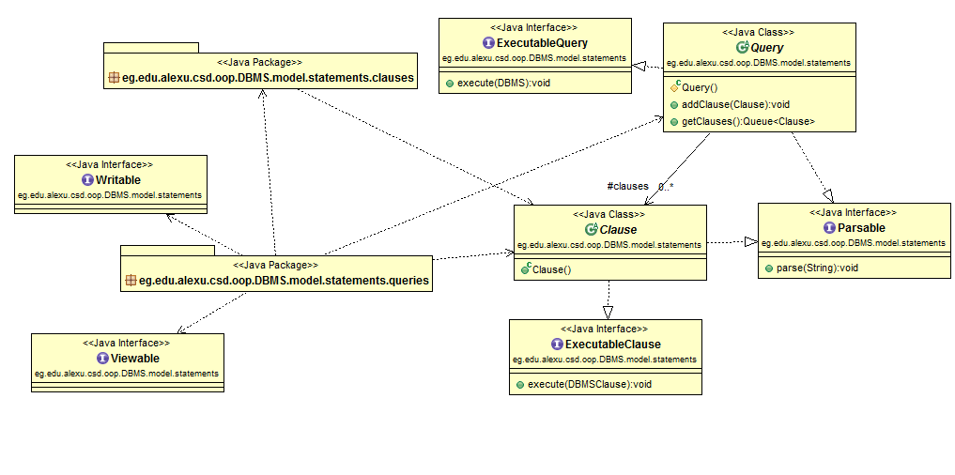

* Clauses and Queries

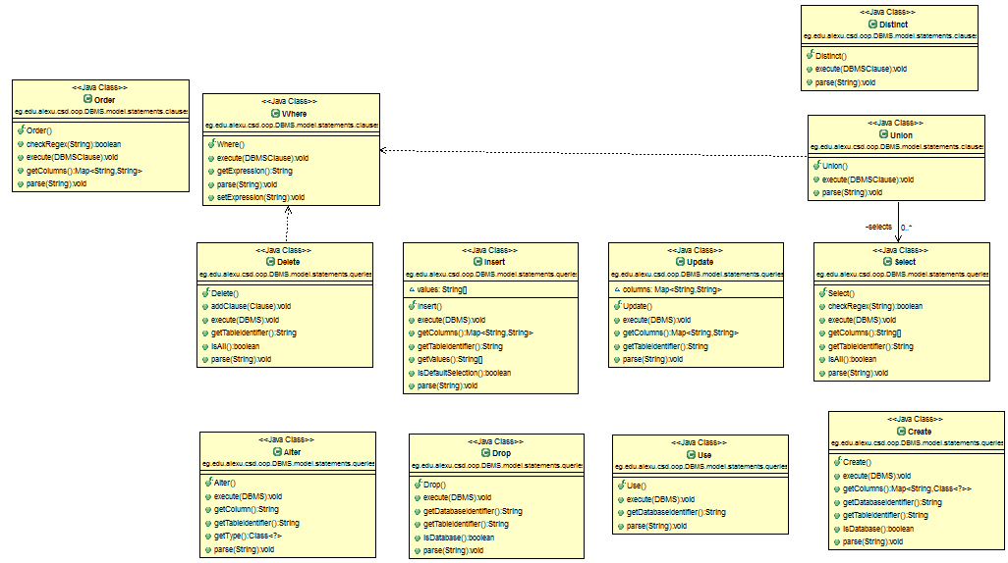

* Util.

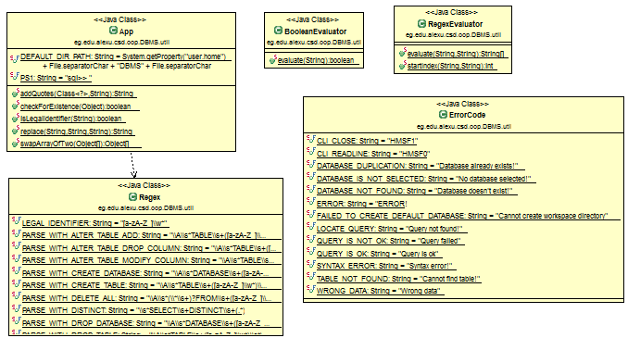

\

* View.

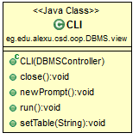

* ***Design.***
* The MVC design pattern is the main used design pattern
* Another design patterns used during the implementation are:
  + Observer Design pattern.
  + Factory Design pattern.
  + Marker Design pattern.
  + Strategy Design pattern.
* ***Design Decisions.***
* The Main decision that was taken to change some parts of the DBMS design to get more extendable application and be able to add the required features and even more if we would like.
* A decision was made to implement the four required features not only two.
* Another decision was made to implement both the two required back end writers not only one so **JSON** and **Protocol** **buffer** were added to the application.
* To implement the “order by” statement we searched online and came up with the decision to use **Apache commons-lang3 3.5** because the **Comparator Chain** class does not support all the utilities that we need to get a very powerful yet simple comparator and the external jar that we’ve used has the same idea of the **Comparator Chain** class but it supports more utilities such as the **Builder**. That provided more extend-ability. Also, it’s used in projects of large scale.
* ***Assumptions.***
* As far as we tested our application we found out that in few test cases when strings contain an odd number of coats this may lead to some problems.
* To represent the “null” value using the protocol buffer we used the string null the difference between this string and any string the user may enter is that to represent the entered string and to use it through the whole application it must be coated.